Circle of Stone and Shadow 2: Mission X ~ LootList
by Pavlovscat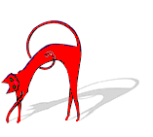09/30/2008

Location | Item | Picture | Qty | Value | Total | Grand Total
BASEMENT
Wine Cellar
first room shelf | fine wine | 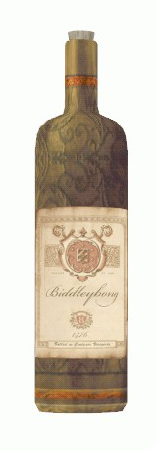 | 1 | 50 | 50 | 50
second room shelf | fine wine |  | 1 | 50 | 50 | 100
in chest | good wine | 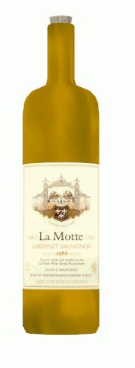 | 1 | 40 | 40 | 140
Barracks
on table | copper coin stack | 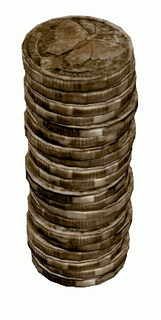 | 1 | 5 | 5 | 145
in chest | gold dice | 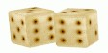 | 1 | 36 | 36 | 181
Accounting
on top shelf | Pomok's blueprints | 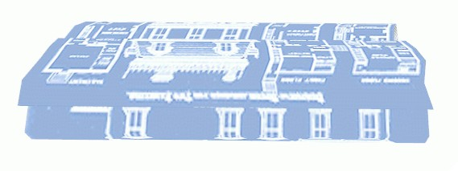 | 1 | 1 | 1 | 182
on table | copper coin stack |  | 5 | 5 | 25 | 207
on table | silver coin stack | 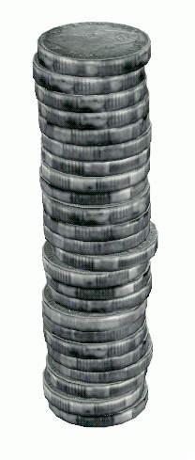 | 4 | 12 | 48 | 255
on table | gold coin stack | 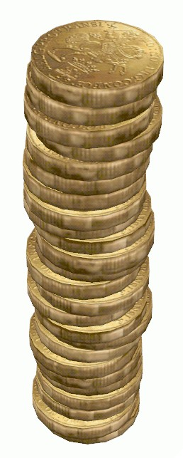 | 4 | 25 | 100 | 355
FIRST FLOOR
Foyer Hall window sill | purple goblet | 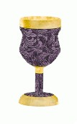 | 1 | 15 | 15 | 370
staff locker on shelf | gold pocketwatch | 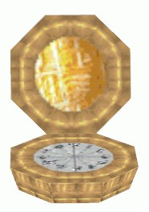 | 1 | 60 | 60 | 430
Foreman's jewelry box | topaz cufflinks | 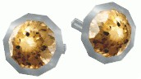 | 1 | 125 | 125 | 555
Guard Captain's | gold torc | 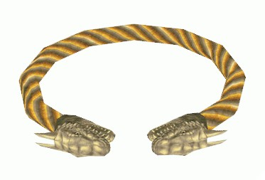 | 1 | 300 | 300 | 715
storage room | hidden stash | 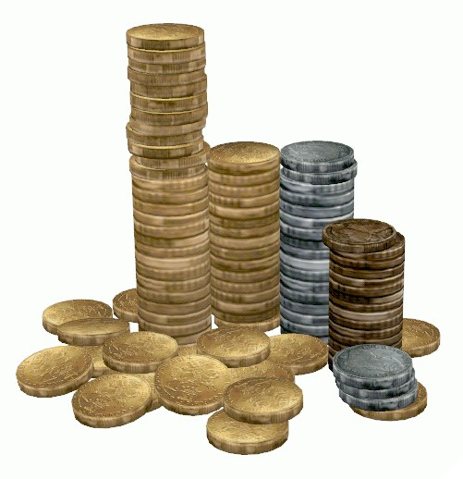 | 1 | 75 | 75 | 930
Pearl Gambling Hall
guard's belt** | purse | 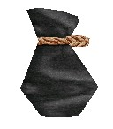 | 1 | 15 | 15 | 945
gambler's belt | purse | 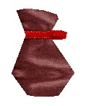 | 1 | 17 | 17 | 962
gambler's belt | purse | 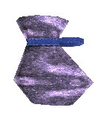 | 1 | 50 | 50 | 1012
gambler's belt | purse | 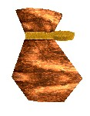 | 1 | 42 | 42 | 1054
gambler's belt | purse | 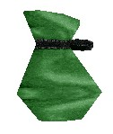 | 1 | 65 | 65 | 1119
gambler's belt | purse |  | 1 | 55 | 55 | 1174
Orchid Dining Hall
on sideboard | decorative plate | 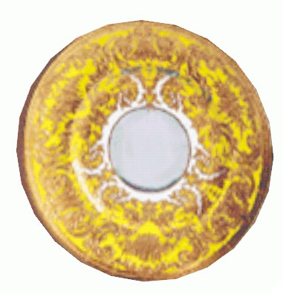 | 2 | 10 | 20 | 1194
on table | silverware | 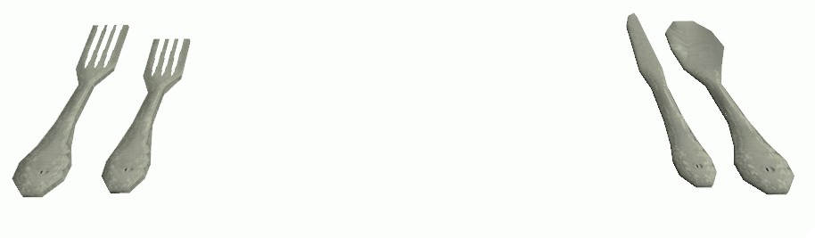 | 12 | 8 | 96 | 1290
Money Exchange Area
lobby | slot machine |  | 3 | 75 | 225 | 1515
green safe in cage | gold bag | 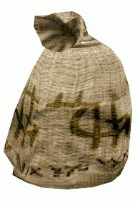 | 2 | 300 | 600 | 2115
on shelf in cage | gold goblet | 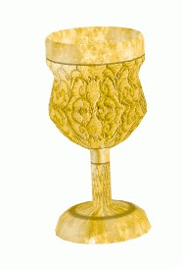 | 1 | 25 | 25 | 2140
on shelf in cage | purple goblet |  | 1 | 15 | 15 | 2155
on shelf in cage | mask | 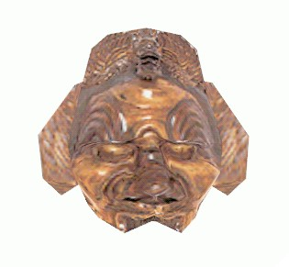 | 1 | 50 | 50 | 2205
on shelf in cage | silver bracers | 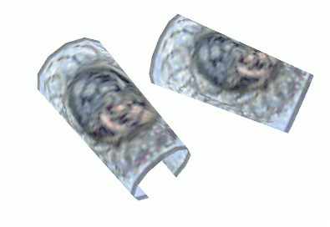 | 1 | 60 | 60 | 2265
on shelf in cage | spice | 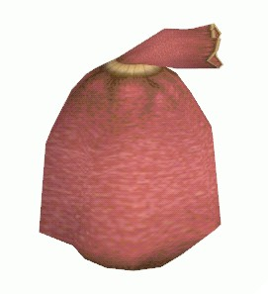 | 3 | 40 | 120 | 2385
combo safe in cage | gold idol | 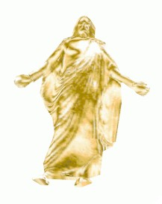 | 1 | 300 | 300 | 2685
combo safe in cage | gold platter | 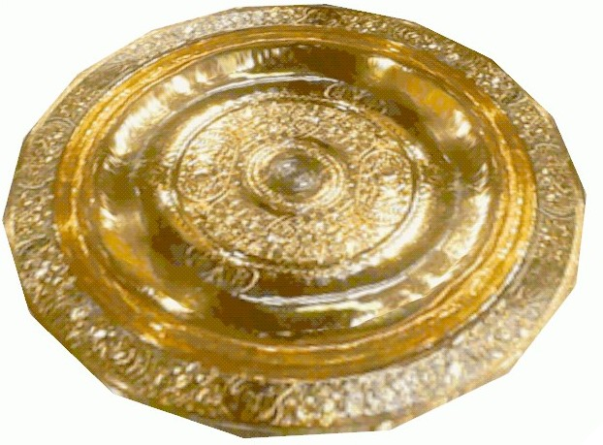 | 1 | 200 | 200 | 2885
SECOND FLOOR
Observation Lounge | gold goblet |  | 1 | 25 | 25 | 2910
Public Bath locker | crystal bracelet | 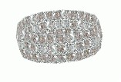 | 1 | 125 | 125 | 3035
207 near bed | gold ring | 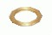 | 1 | 100 | 100 | 3135
208 on table | fine wine |  | 1 | 50 | 50 | 3185
209 on dresser | purse | 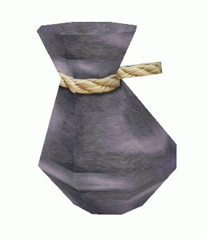 | 1 | 50 | 50 | 3235
211 in jewelry box | gold locket | 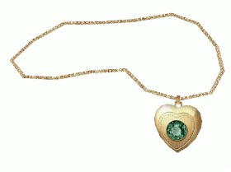 | 1 | 150 | 150 | 3385
211 in chest | amethyst brooch | 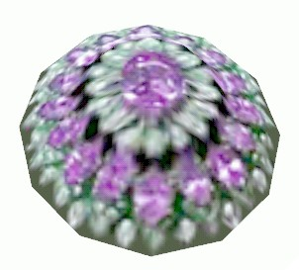 | 1 | 125 | 125 | 3510
Stormcloud's Clubhouse
hallway | slot machine |  | 4 | 75 | 300 | 3810
fireplace in den | gold candlestick | 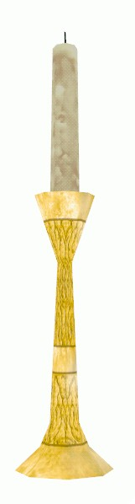 | 2 | 50 | 100 | 3910
desk in office | silver locket | 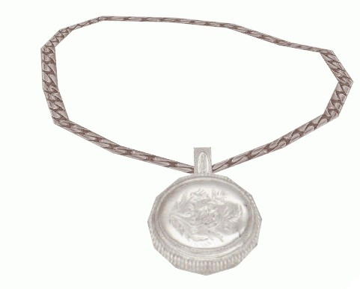 | 1 | 50 | 50 | 3960
table near bar | purple goblet |  | 1 | 15 | 15 | 3975
THIRD FLOOR
restroom, ladies' | sapphire ring | 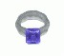 | 1 | 200 | 200 | 4175
Ambassador Suite bath | gold pitcher | 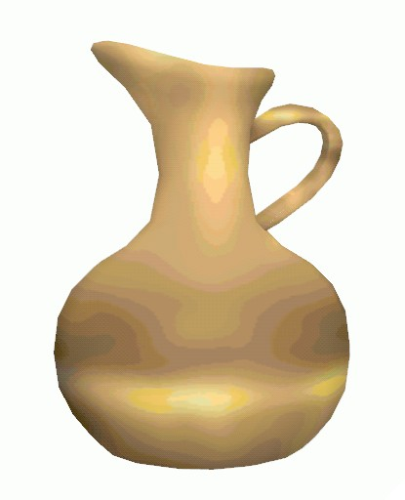 | 1 | 75 | 75 | 4250
Mahogany Hall couch | purse |  | 1 | 50 | 50 | 4300
Minister's Suite
in chest | gold headband | 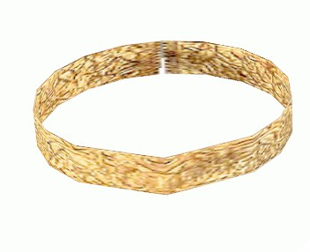 | 1 | 75 | 75 | 4375
in chest | aquamarine earrings | 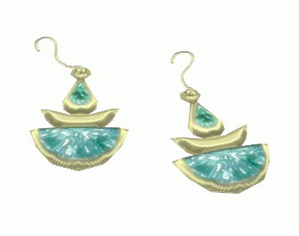 | 1 | 185 | 185 | 4560
in bath | silver ewer | 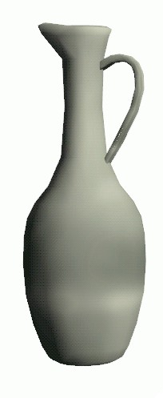 | 1 | 30 | 30 | 4590
Theater Dressing Room
on desk | silver mirror | 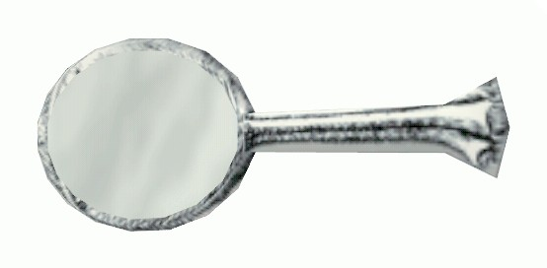 | 2 | 10 | 20 | 4610
on desk | silver brush | 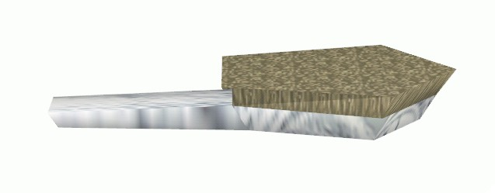 | 1 | 8 | 8 | 4618
on desk | silver comb | 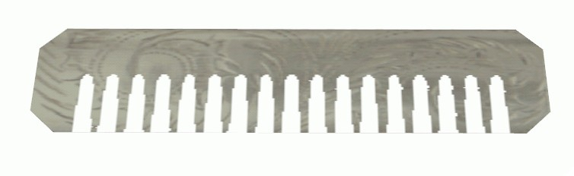 | 1 | 10 | 10 | 4628
on desk | perfume | 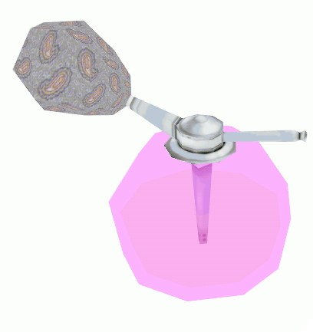 | 1 | 70 | 70 | 4698
on cabinet | trophy | 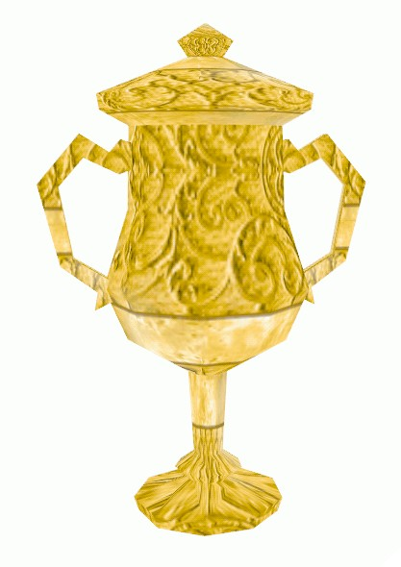 | 1 | 75 | 75 | 4773
in cabinet | gold necklace | 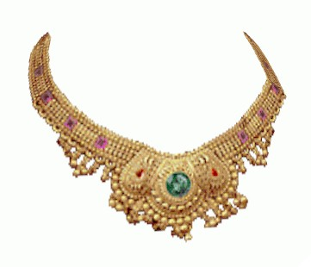 | 1 | 270 | 270 | 5043
in cabinet | tiara | 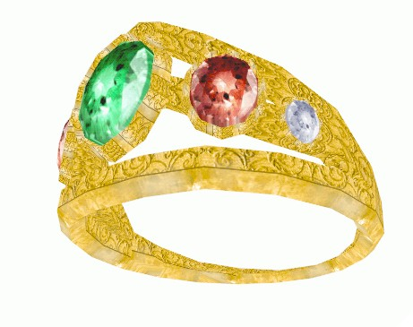 | 1 | 125 | 125 | 5168
Pine Lounge
behing bar | fine wine |  | 1 | 50 | 50 | 5218
on table | gold goblet |  | 1 | 25 | 25 | 5243
Duke's Suite
in cabinet | gold bracelet | 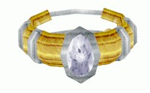 | 1 | 125 | 125 | 5368
on table | ruby cuff links | 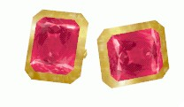 | 1 | 300 | 300 | 5668
Monarch's Suite
in closet | fancy necklace | 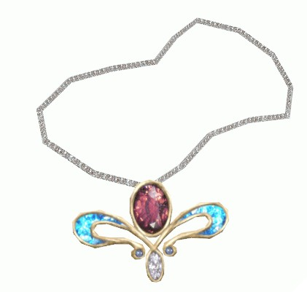 | 1 | 300 | 300 | 5968
in closet | rare coin | 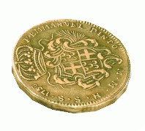 | 1 | 50 | 50 | 6018
in bath | gold jug | 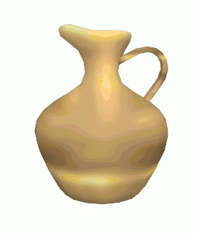 | 1 | 80 | 80 | 6098
in hutch | headband | 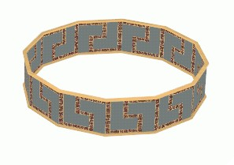 | 1 | 25 | 25 | 6123
in cabinet | gold pocketwatch |  | 1 | 60 | 60 | 6183
on dresser | decorative plate | 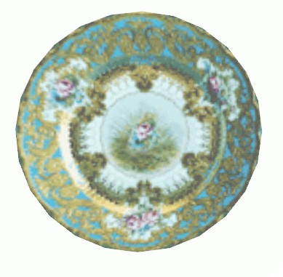 | 2 | 10 | 20 | 6203
on nightstand | fine wine |  | 1 | 50 | 50 | 6253
on nightstand | gold goblet |  | 1 | 25 | 25 | 6278
craps table | gold dice |  | 2 | 36 | 72 | 6350
table near poker game | silver flute | 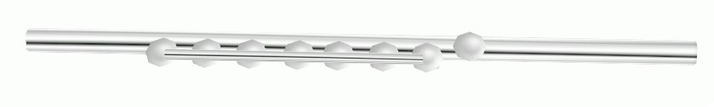 | 1 | 50 | 50 | 6400
poker table | topaz gem | 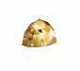 | 1 | 110 | 110 | 6510
poker table | garnet gem | 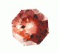 | 1 | 25 | 25 | 6535
poker table | copper coin stack |  | 2 | 5 | 10 | 6545
poker table | silver coin | 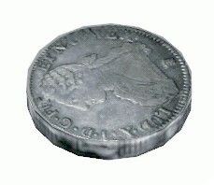 | 3 | 1 | 3 | 6548
poker table | silver coin stack |  | 3 | 12 | 36 | 6584
poker table | gold coin | 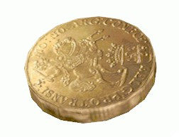 | 1 | 1 | 1 | 6585
poker table | gold coin stack |  | 4 | 25 | 100 | 6685
poker table | gold coin pile | 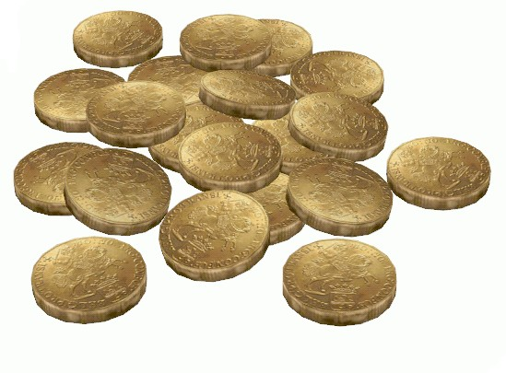 | 2 | 20 | 40 | 6725
poker table | large coin stack |  | 2 | 75 | 150 | 6875
poker table | spilled purse | 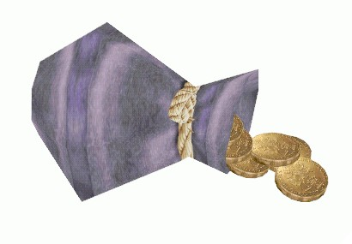 | 1 | 50 | 50 | 6925
FOURTH FLOOR
Oak Theater balcony railing | gold reading glasses | 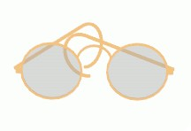 | 1 | 50 | 50 | 6975
Records on shelf | coin | 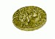 | 1 | 5 | 5 | 6980
Chief Bookkeeper | green vase | 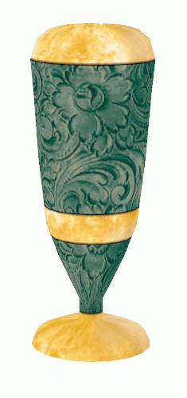 | 1 | 50 | 50 | 7030
Cloud's belt | purse |  | 1 | 40 | 40 | 7070
Head Accountant's safe | gem pile | 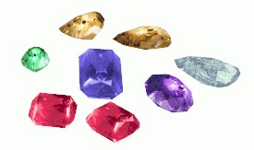 | 1 | 500 | 500 | 7570
Civil Litigation on desk | gold pipe | 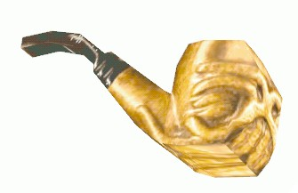 | 1 | 50 | 50 | 7620
Criminal Litigation on shelf | silver magnifier | 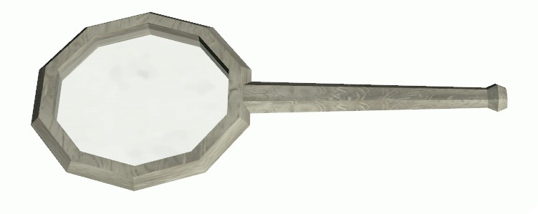 | 1 | 5 | 5 | 7625
Cloud's Office | good wine |  | 1 | 40 | 40 | 7665
Mahogany Hall scaffolds | rare coin |  | 1 | 50 | 50 | 7715
Cloud's Suite
on table | gold vase | 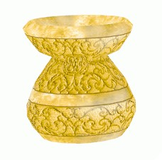 | 1 | 100 | 100 | 7815
on rear table | scattered coins | 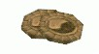 | 1 | 20 | 20 | 7835
on rear table | good wine |  | 1 | 40 | 40 | 7875
on rear table | purple goblet |  | 2 | 15 | 30 | 7905
on dresser | purple vase | 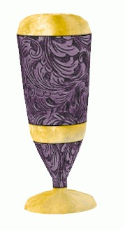 | 1 | 50 | 50 | 7955
in bedroom cabinet | diamond necklace | 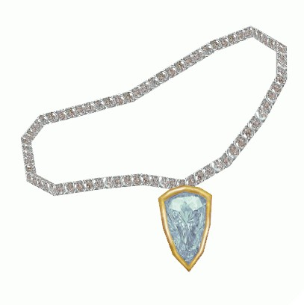 | 1 | 225 | 225 | 8180
on bath table | silver mirror |  | 1 | 10 | 10 | 8190
on bath table | silver comb |  | 1 | 10 | 10 | 8200
on bath table | perfume |  | 1 | 70 | 70 | 8270
near tub | gold vessel | 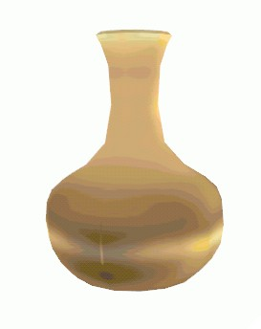 | 1 | 70 | 70 | 8340
near tub | silver carafe | 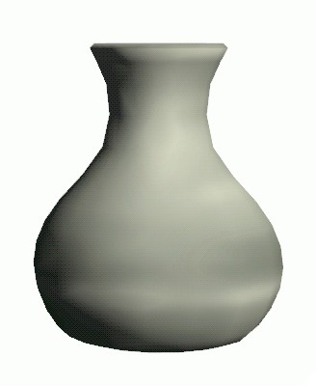 | 1 | 45 | 45 | 8385

**If Raputo’s Guard stationed in the casino leaves the map before you pick his purse, the
amount in his purse will be subtracted from the total, leaving only 8370.
Thanks for playing CoSaS 2: Mission X!!

